* Download the predix seed app either directly from the link

<https://github.com/PredixDev/predix-seed.git> or using Git clone url command in cmd.

* The downloaded predix seed app will have by default some folders like 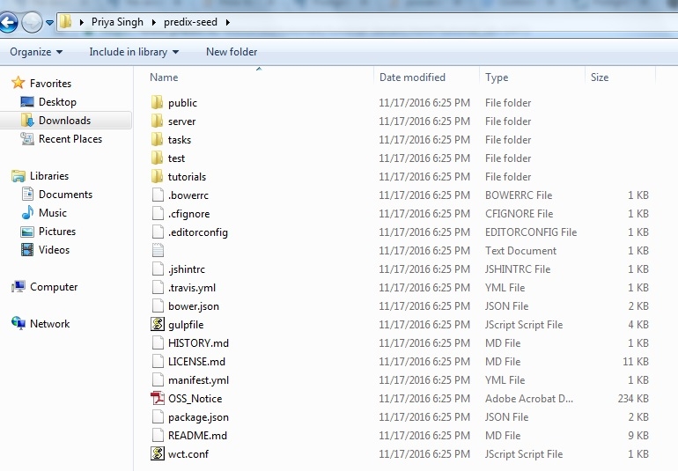
* Set the paths and proxy settings needed.

set path=C:\Users\Program Files\nodejs; C:\Users\rb842469\AppData\Roaming\npm;C:\Program Files (x86)\Git\bin;%path%

set HTTP_PROXY=http://proxy-src.research.ge.com:8080

set HTTPS_PROXY=http://proxy-src.research.ge.com:8080

set http_proxy=http://proxy-src.research.ge.com:8080

set https_proxy=http://proxy-src.research.ge.com:8080

set no_proxy=.ge.com

* Public is the folder which is the heart of ui app .It will have all views and js files.
* Do the

1. set path=%path%;<path where you npm is placed>

for eg. set path=%path%; C:\Users\ps842449.IGATEGEGDC\AppData\Roaming\npm;

1. npm install 🡪To install the node modules components .To run the npm commands nodejs should be already installed. The main component in node modules is grunt.
2. bower install 🡪bower components folder will be inside public folder.

for bower components GIT must be already installed.

If you run just bower install we can download the basic bower components.

If we need any additional components like heatmaps to be installed then use the

commands accordingly to component.

For eg. bower install highcharts

bower install datatables

1. grunt clean --force
2. grunt dist –force (If you want to deploy to the Cloud.)
3. grunt serve (for running your application locally.)

* If you want to change the
* index.html is the first file to be loaded when we start running the application.

<section role="region" ui-view></section>

This the area where all html files content will be loaded.

<px-app-nav class="navbar" nav-items="{{App.tabs}}" path-prefix="/" path-key="state">

This tag will be used for application navigation tabs.

app.js file will have values of "{{App.tabs}}.

tabs: [

{icon: 'fa-tachometer', state: 'dashboards', label: 'Dashboards'}

]

1. we will mention the navigation details for all states mentioned in tabs in routes.js , navigation details for each state contains the url , templateUrl, controller .

.state('dashboards', {

// parent: 'secure',

url: '/dashboards',

templateUrl: 'views/dashboards.html',

controller: 'DashboardsCtrl'

})

If we uncomment the parent then everytime if you are going to load the html file

main.js will define all the controllers whatever we used in the UI app.

* Navigation sidebar

Navigation menu will be at the left corner.

From that we can keep the icon whatever we need in our choice.

In app.js under tabs : Icon name, State, Label & Sub-items will be mentioned

1. For identifying the icons name two methods are there:

1. http://gesdh.com and we want to give SSO ID and Pwd to Login

Click on Predix Design System -> Basics -> Icons where we can easily find name and

design of the icon.

OR <http://gesdh.com/industrial-internet/docs/icons>

2.In predix seed app ->public -> bower components -> font -> font awesome here we

can find only the class names of the Icon where we can try different Icons and get the appropriate Icon we need.

3. Direct link <http://www.w3schools.com/icons/fontawesome_icons_webapp.asp>

<http://fontawesome.io/icons/>

2.State -> State is the common key for routes and app.js .State name will be same as of routes name.

3.Label -> Name that should be displayed on the navigation bar.

4.Sub items -> Sub items are items that are displayed under one menu.

We can’t keep icon on the sub items. Just one intended space will be automatically allocated while we creating the sub items.

Px-app-nav -> We can’t customize anything what we need because it will affect the entire component.

For Customizing we can go for custom.css from that we can change label color, background color etc..

* We want to use class name to customize the specific content

In navigation bar there will be a default Sign In which will be present in px-login page where some

Validations are given for users to Sign In

In app.js under tabs: we can add any new menu items and sub menu items that are necessary for us.